HEARING – sense that converts vibrations of air into nerve impulses that are interpreted by the brain as sound.

ROOTS: oto- ear, myringo- eardrum

MAIN COMPARTMENTS OF THE EAR: external, middle, and inner ear, which are all located in a hollowed out area of the temporal bone.

EXTERNAL EAR CANAL

FUNCTION: acts as a funnel to collect sound wave vibrations and direct them to the eardrum.

_____________: visible part of the ear; funnel-shaped, made up of cartilage; mobile in many species

EXTERNAL AUDITORY MEATUS: L-shaped tube extending from the pinna to the ear drum

__________________ ________________: ear drum; thin membrane that separates the external and middle ear; vibrates when sound vibrations strike it

MIDDLE EAR CANAL

FUNCTION: amplifies and transmits the vibrations from the ear drum to the inner ear

________________: 3 small bones that transmit sound wave vibrations from the TM to the cochlea (they decrease the size of the vibrations, but amplify their force)

______________ (attached to the TM), _____________, _____________ (covers the oval window)

_____________________ __________: connects the middle ear with the pharynx; equalizes the air pressure on either side of the TM. Yawning/swallowing allows air to enter or exit the ET, equalizing the pressure in the middle ear with the outside air and preventing the TM from bulging in either direction

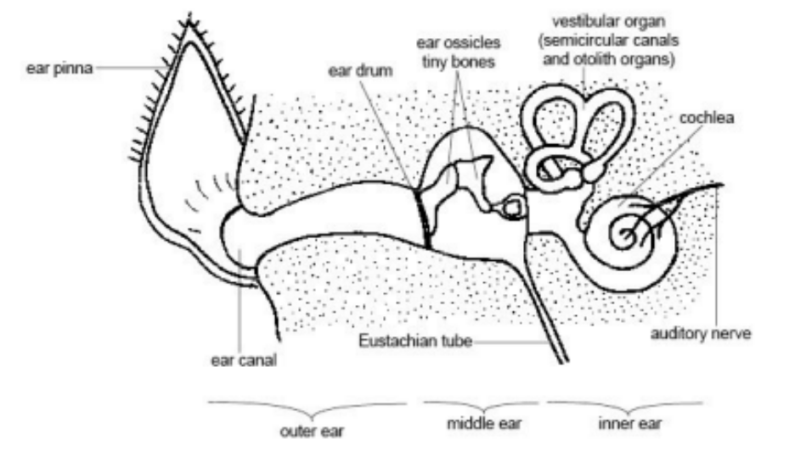

INNER EAR CANAL

FUNCTION: contains the sensory receptors that convert the mechanical vibrations to nerve impulses; also contains receptors for equilibrium. Begins at the oval window which is covered by the stapes

_______________: snail-shaped cavity that contains the Organ of _________. Vibration of the stapes against the oval window causes fluid to move within the Organ of Corti. Cells lined with cilia in the organ of corti will then bend which sends nerve impulses to the brain via the vestibulocochlear nerve to interpret as sound.

STRUCTURES OF EQUILIBRIUM: the VESTIBULE and SEMICIRCULAR CANALS

The Vestibule contains 2 sacs (Utricle and Saccule). Each sac is fluid-filled and has a macula, a structure lined with hair that is covered with otoliths (“ear stones”). Movement in a straight line causes the hair to bend and this message is sent to the brain via the vestibulocochlear nerve.

The Semicircular Canals respond to turning (rotary) movement. They are 3 canals that are positioned at right angles to each other. Each is lined with hair and filled with fluid. Turning the head causes the fluid to move in at least one of the canals, which bends the hair and sends a signal to the brain via the vestibulocochlear nerve.

INCLUDEPICTURE "http://4.bp.blogspot.com/_rMxqYV-oHvk/R4rYCB0LurI/AAAAAAAABF8/Wea8mZyVGGI/s400/ear-anatomy-picture.jpg" \* MERGEFORMATINET INCLUDEPICTURE "http://4.bp.blogspot.com/_rMxqYV-oHvk/R4rYCB0LurI/AAAAAAAABF8/Wea8mZyVGGI/s400/ear-anatomy-picture.jpg" \* MERGEFORMATINET 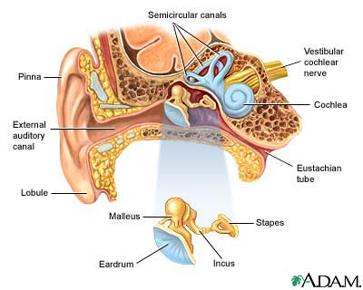 INCLUDEPICTURE "http://www.tooloop.com/wp-content/uploads/2013/12/inner-ear-diagram-labeled.jpg" \* MERGEFORMATINET 

